OTC Flow

Click on Order Management tile

Task > Create Order

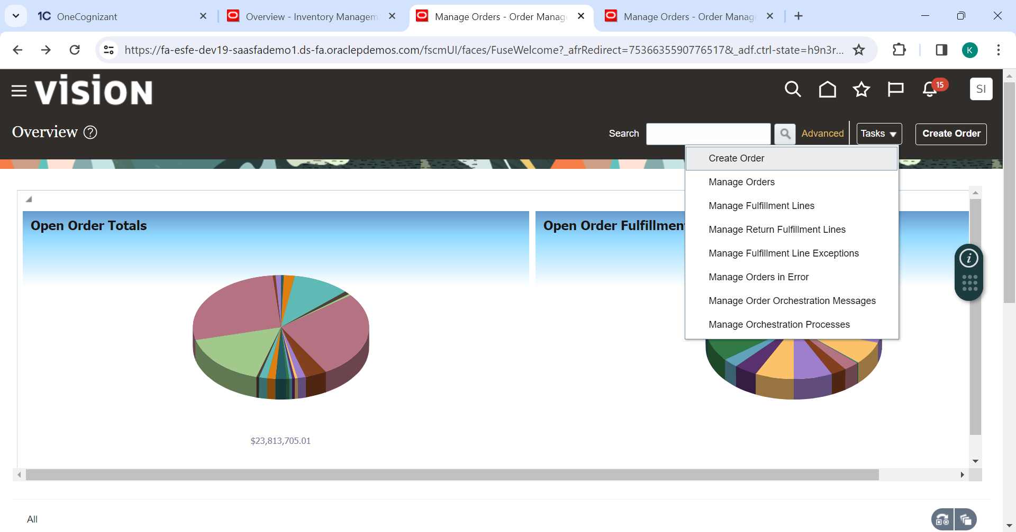

Create Sales Order with detail as below

Header

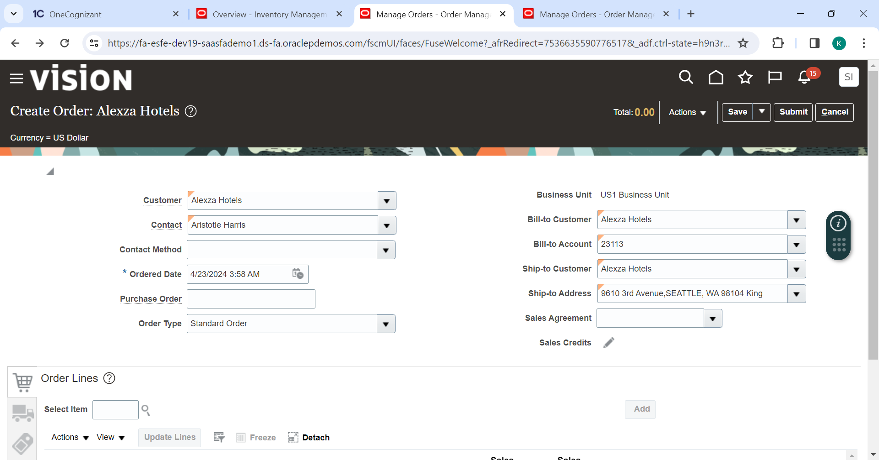

Line

Entered item as Cooking Oil

Click Add

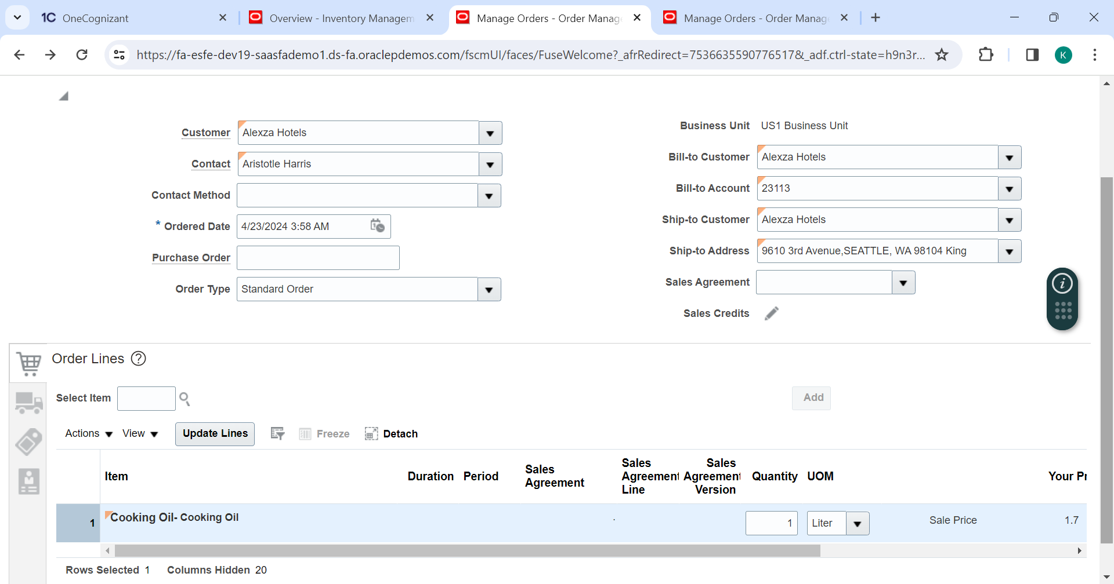

Enter Warehouse under Shipment detail

Verify receivables transaction is populated under Billing & Transaction detail

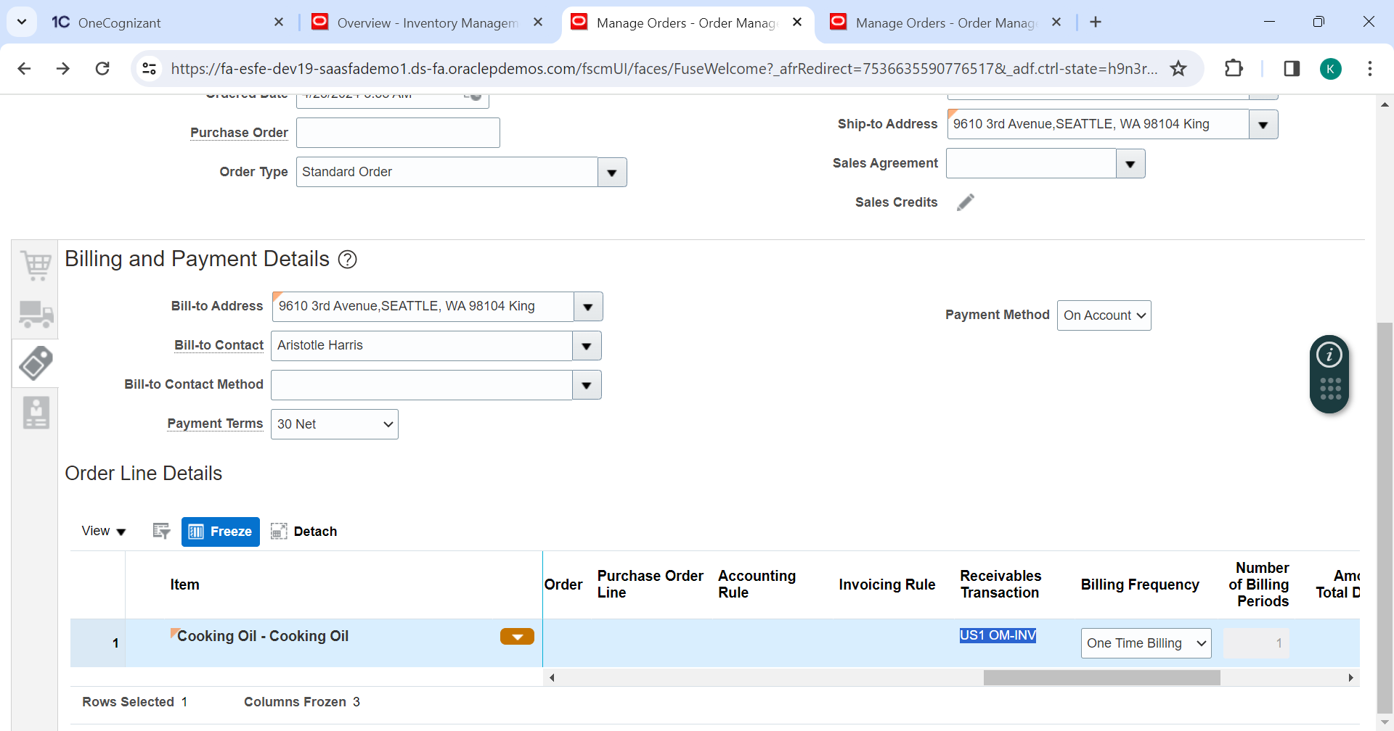

Verification of on hand quantity for selected item

Navigate to Inventory Management

More than Sufficient quantity is present on hand to proceed with the transaction

On the create order screen save and submit the transaction

Click Ok

Status got flipped to Awaiting Shipping

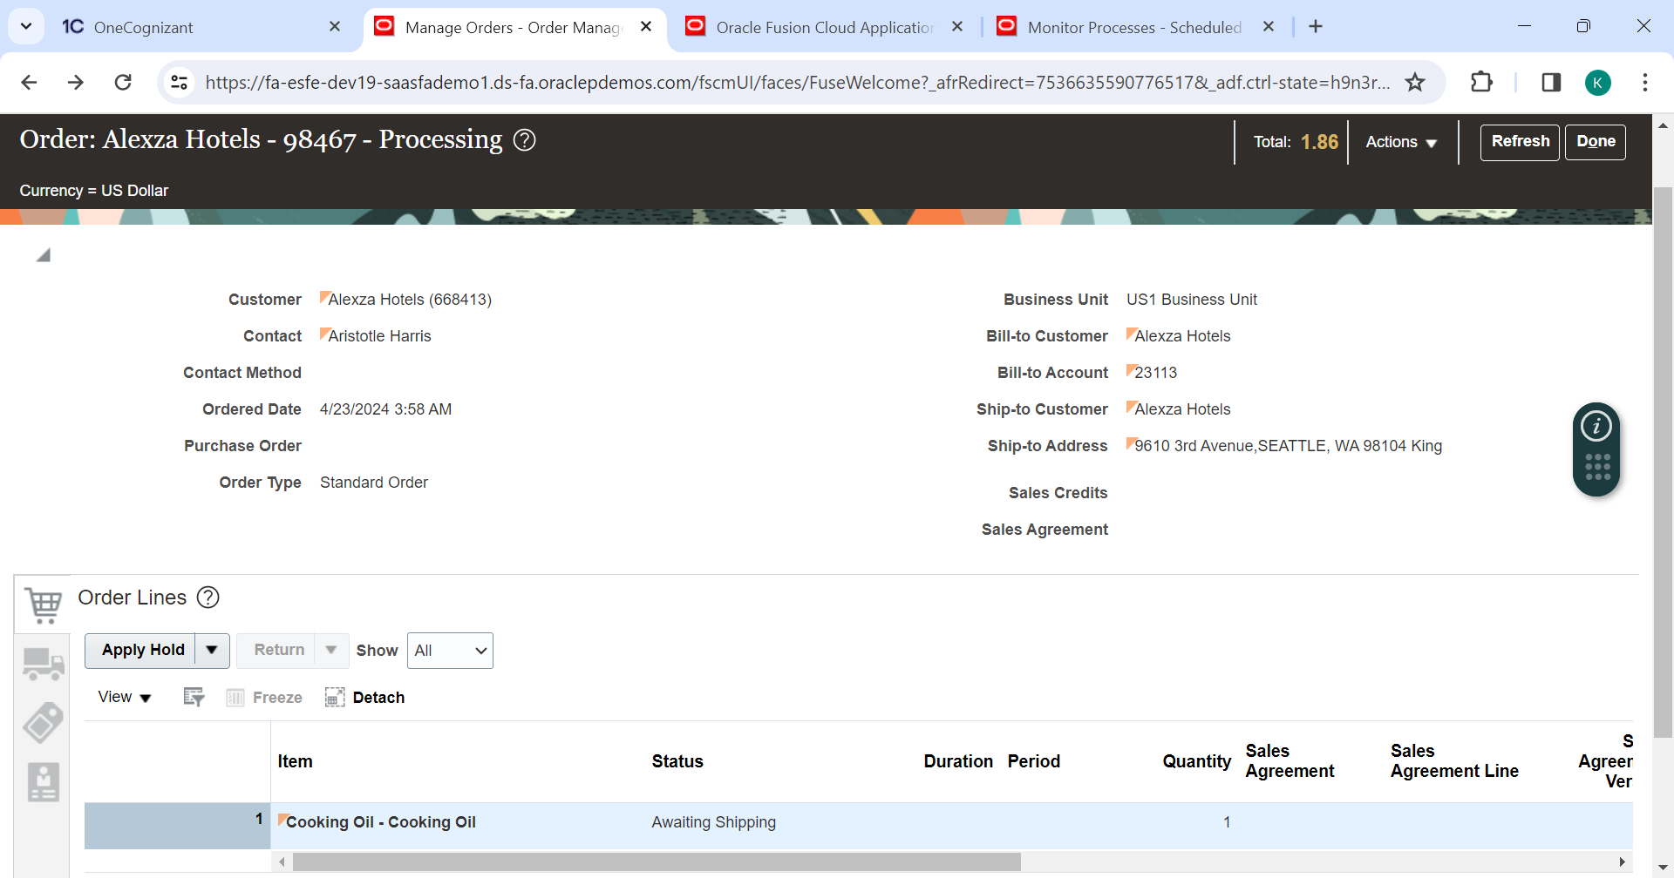

Navigate to Inventory and perform pick wave

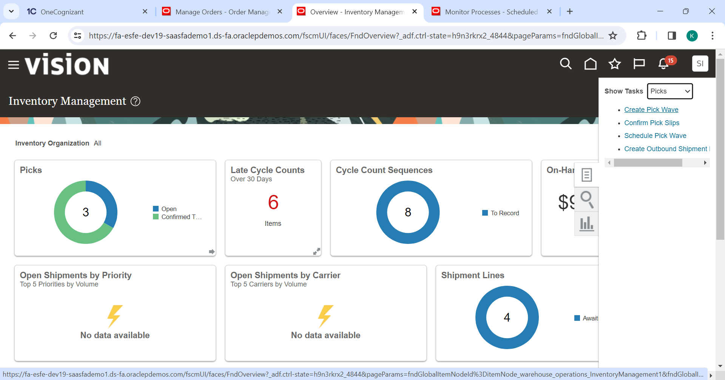

Provide Ship Form org, Sales Order#

Click Show More

Enable highlighted checkboxes and entries.

Then click Release now in the top

Navigate back to Manage Orders and check the status flipped to Shipped (May take couple of minutes)

Refresh again

Status will get flipped to Awaiting Billing.

Navigate to Tools > Scheduled Process > Create New Process > Import Autoinvoice

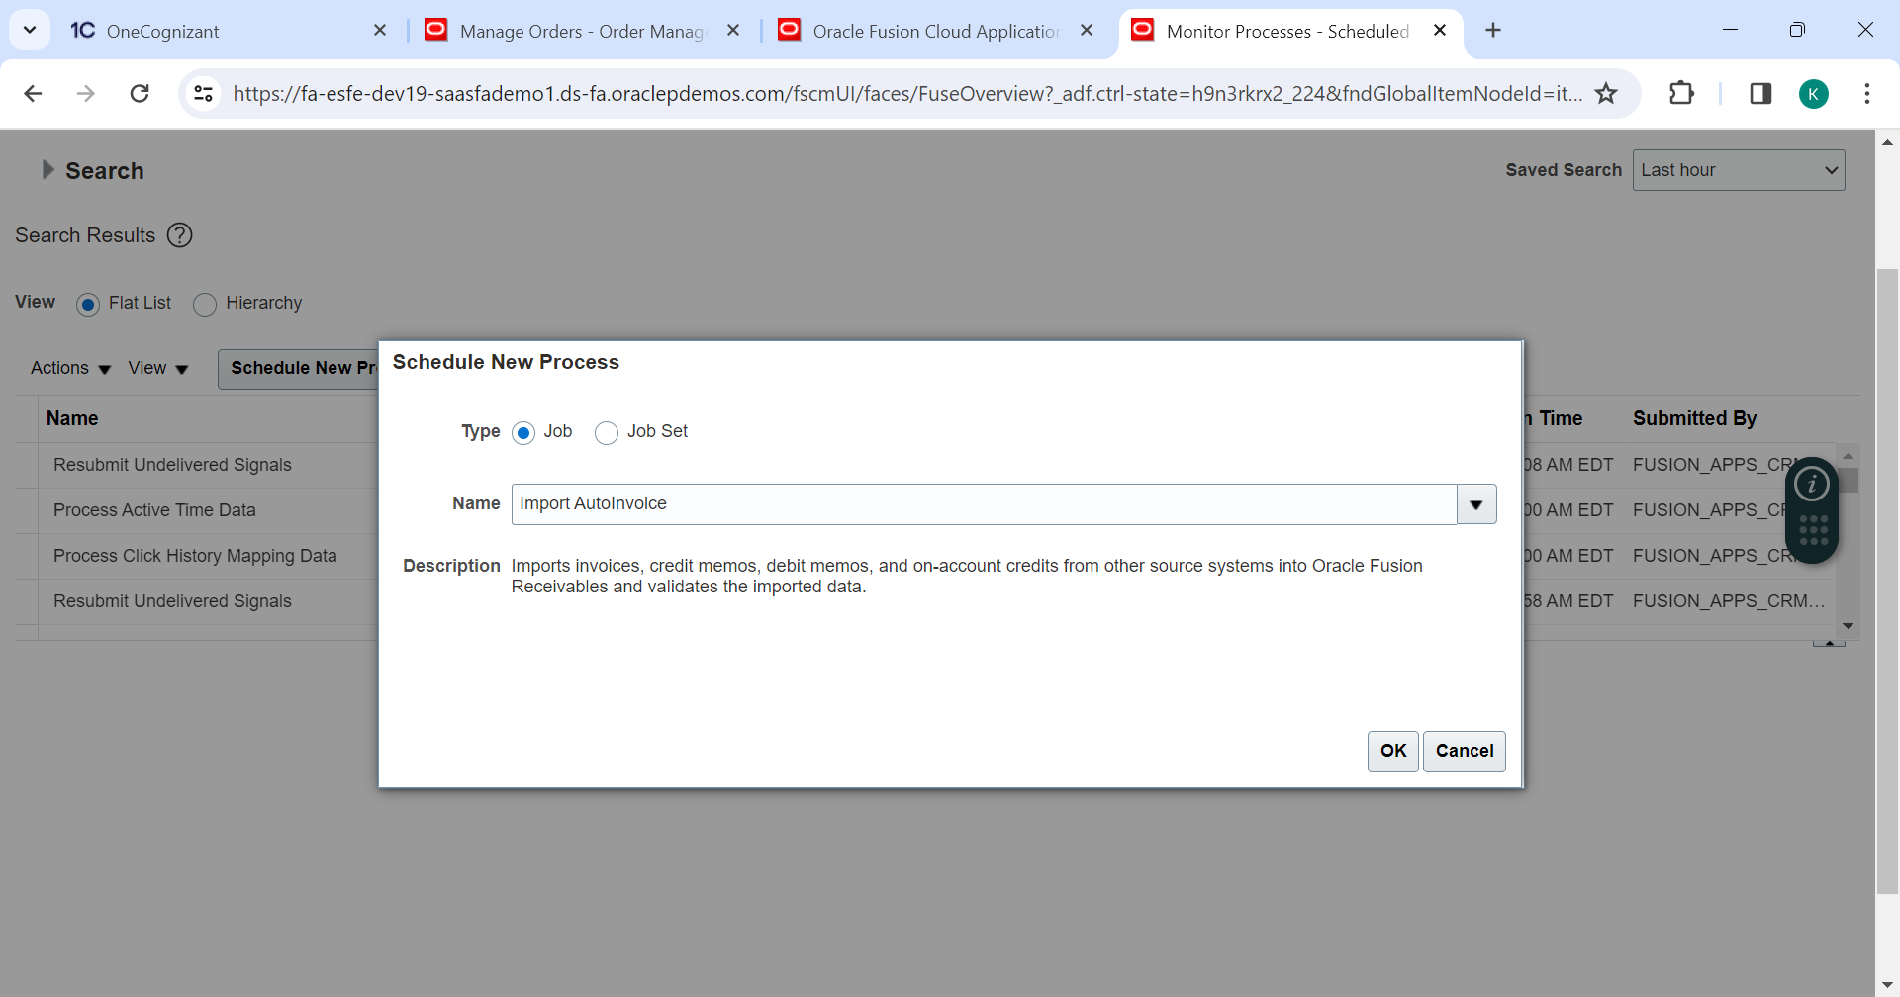

Enter BU, Transaction Source, From & To Sales Order # and Click Submit

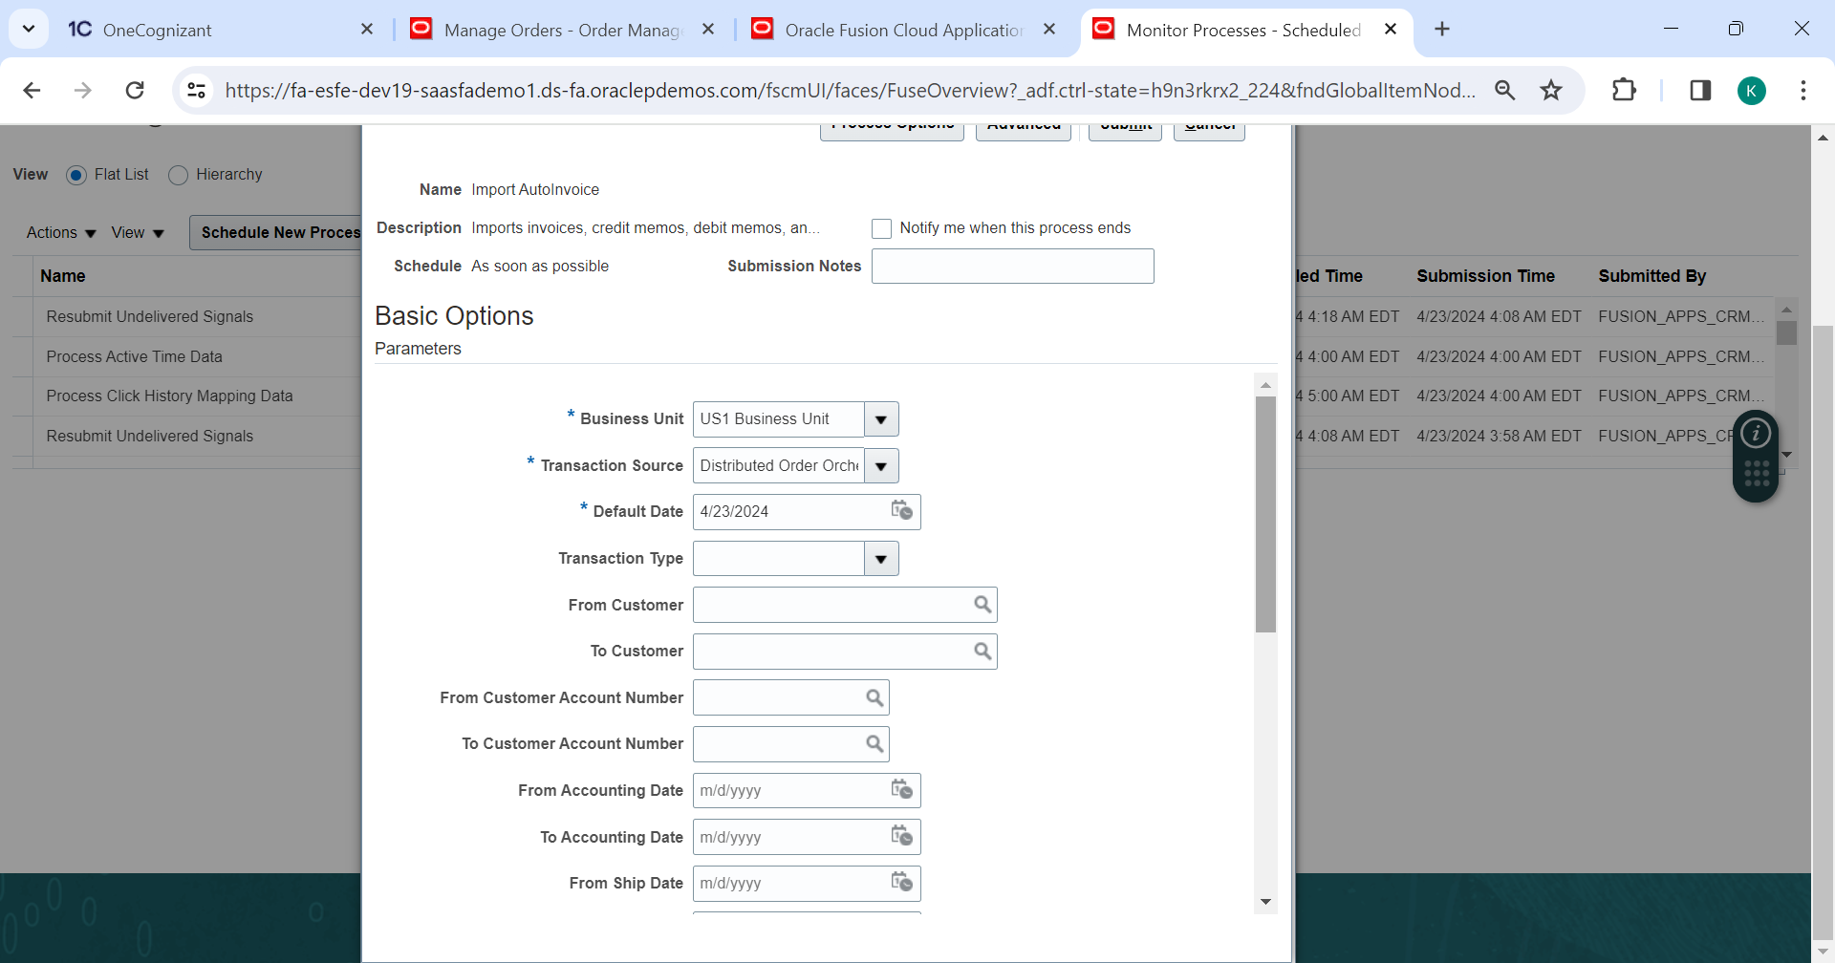

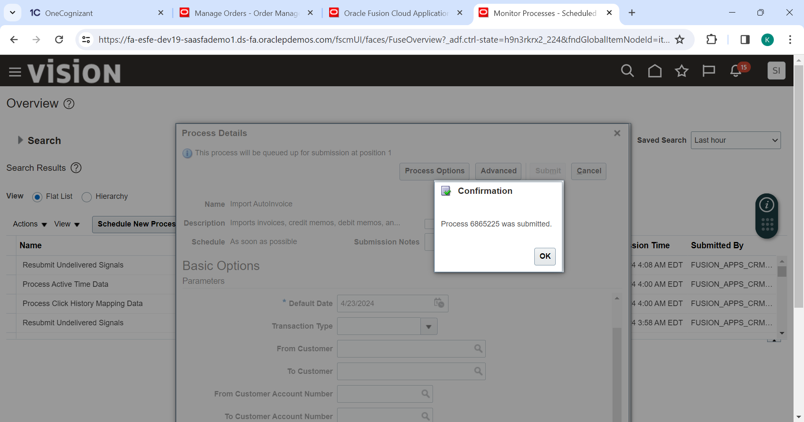

Navigate back to Manage order and provide the sales order #

Status now should be billed

Upon refreshing again status will be Closed.

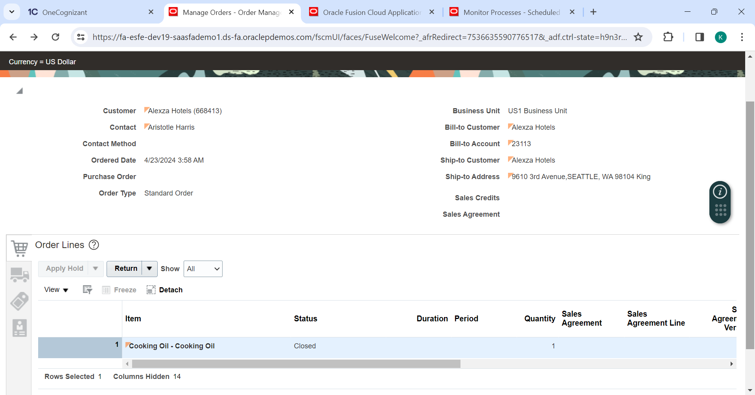

Actions > Switch to Fulfillment View

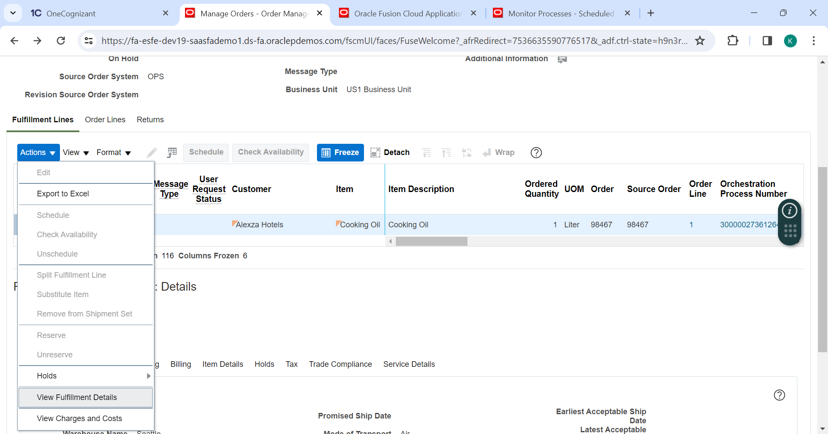

Verifying the invoice # in receivables (Navigate to Receivables > Billing)

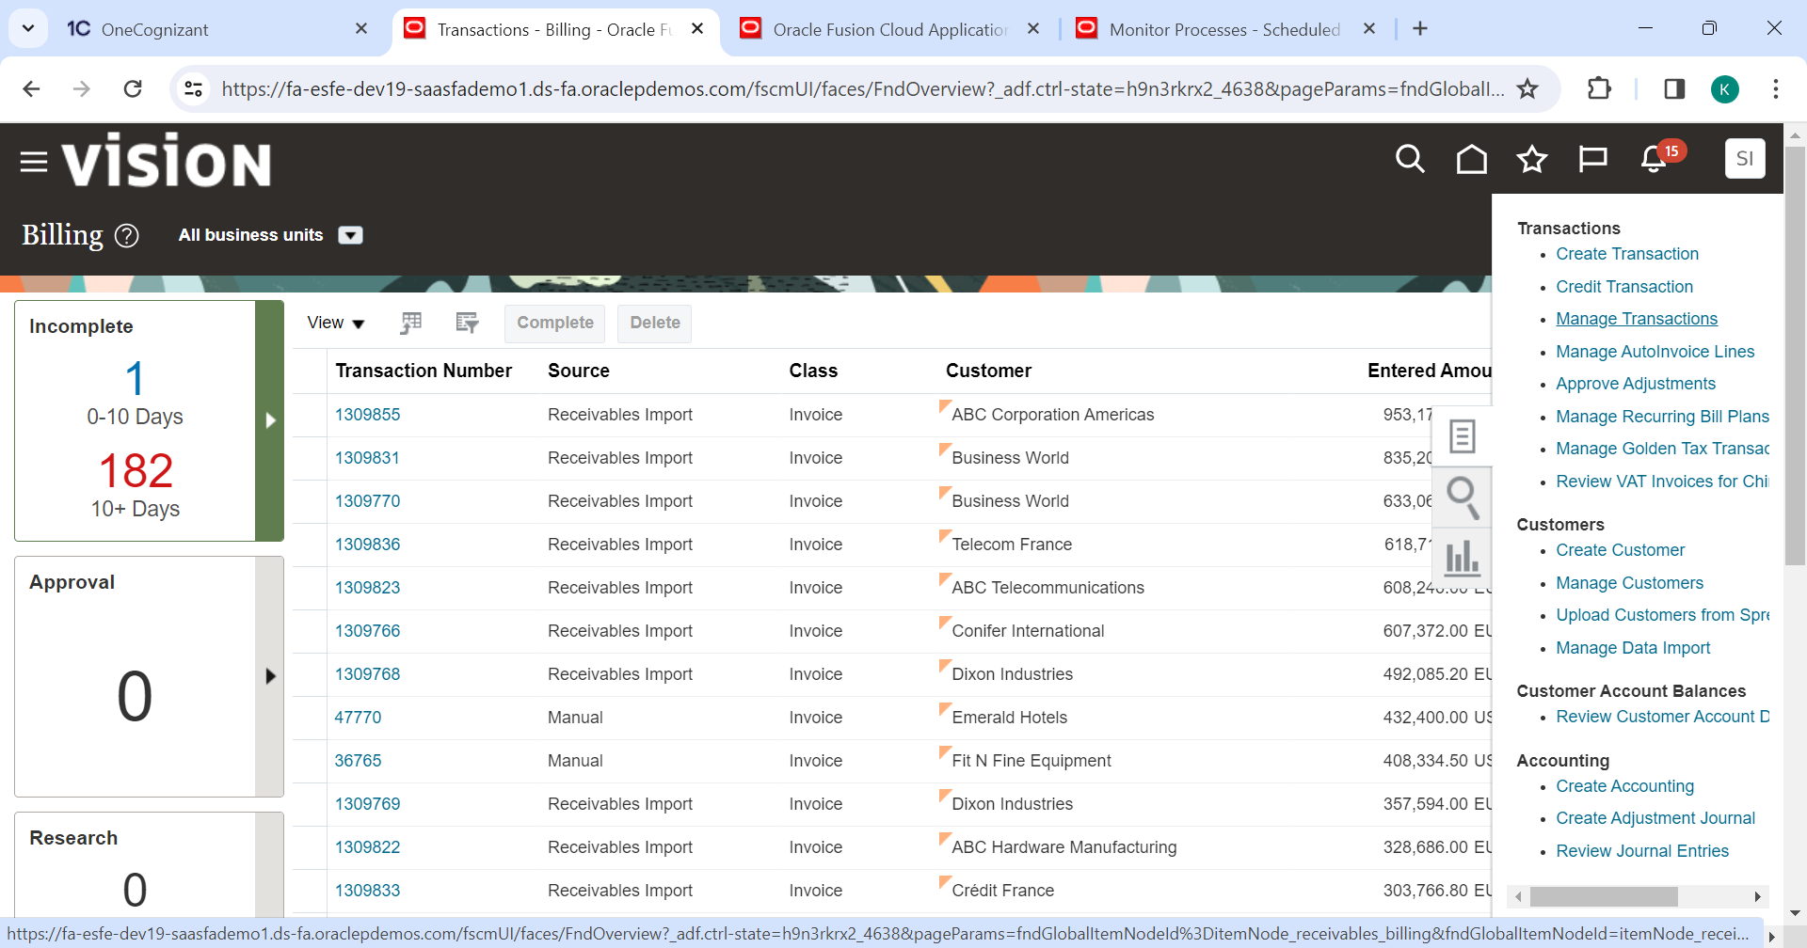

Provide invoice # in transaction# field and hit search

View Accounting

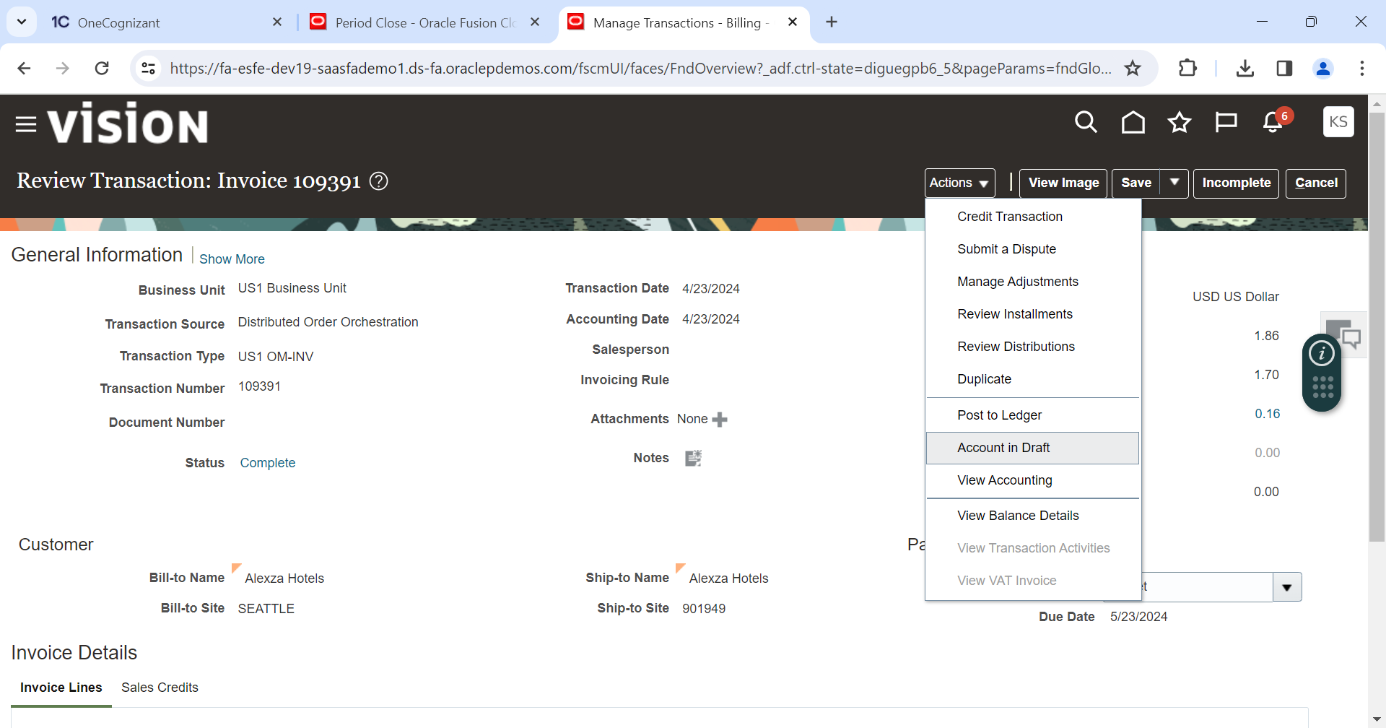

Click Account in Draft

